Software Design Specification
____________________________________________________________

Project Title: | Plant Disease Detection App (Agro Guard App)
Project Code: | Group 40
Internal Advisor: | Dr. Hussam Ali
Externa Advisor: | N/A
Project Manager: | Prof. Dr. Muhammad Iliyas
Project Team: | M Taha Mukhtar BSCS51F22S004 (Team Lead)  Hammad Ahmad BSCS51F22S012 (Team Member) Usama Farooq BSCS51F22S045 (Team Member)
Submission Date: | December 15, 2025



__________________________
Project Manager's Signature

Document Information
Category | Information
Customer | UOS – Department of Computer Science
Document | Software Design Specification
Identifier | Group 40
Author(s) | Muhammad Taha Mukhtar  Hammad Ahmad  Usama Farooq
Project | AI powered Plant Disease Detection App (AgroGuard)
Document Version | 2.0
Status | Approved
Approver(s) | PM
Issue Date | October 20, 2025

Definition of Terms, Acronyms and Abbreviations.

AI | Artificial intelligence
GPS | Global Positioning System
ML | Machine Learning
API | Application Programming Interface
MVVM | Model View View Model
HF | Hugging Face
TFLite | TensorFlow Lite

Table of Contents
1. Introduction ............................................................................................................. 4
1.1 Purpose of Document .......................................................................................... 4
1.2 Project Overview .................................................................................................. 4
1.3 Scope ..................................................................................................................... 4
2. Design Considerations ............................................................................................... 4
2.1 Assumptions and Dependencies .......................................................................... 5
2.2 Risks and Volatile Areas ....................................................................................... 5
3. System Architecture ................................................................................................... 5
3.1 System Level Architecture .................................................................................... 7
3.2 Sub-System / Component / Module Level Architecture ..................................... 8
3.3 Sub-Component / Sub-Module Level Architecture (1…n) .................................. 9
4. Design Strategies ..................................................................................................... 11
4.1 Strategy 1…n ...................................................................................................... 11
5. Detailed System Design ........................................................................................... 12
6. References ................................................................................................................ 17

1. Introduction

1.1 Purpose of Document
This document provides a comprehensive design specification for the AI Plant Disease Detection mobile application. It is intended for the development team, project supervisors, and technical reviewers who will evaluate the system architecture and implementation approach. This document will serve as a blueprint for the development process, outlining the system architecture, design strategies, and technical considerations.

1.2 Project Overview
The AI Plant Disease Detection App is a mobile application designed to assist farmers in identifying plant diseases through image recognition technology. The application leverages artificial intelligence and machine learning to analyze photographs of crops and provide instant diagnosis of plant health conditions.

The system supports disease detection for multiple crop types including corn, oranges, potato, mango, lemon and apple. Upon capturing or uploading an image of a plant, the application processes the image and sends it to a remote Hugging Face-hosted inference server, where TensorFlow Lite models classify the disease. The application then provides farmers with detailed information about the identified disease, including descriptions and recommended treatments. Additionally, the app integrates weather information relevant to the farmer's location and an AI-powered agricultural chatbot powered by the Groq API (Llama 3.3 70B), helping them make informed decisions about crop management.

1.3 Scope
The system will:
- Provide a mobile application interface for capturing or uploading plant images
- Support disease detection for different crop plants such as corn, orange, potato, mango, apple, and lemon
- Send plant images to a remote TFLite inference server hosted on Hugging Face for disease classification
- Provide detailed descriptions of identified diseases
- Suggest practical treatment options for detected plant diseases
- Display real-time weather information based on the user's geographical location
- Integrate an AI-based chatbot (AgroBot) powered by Groq API for treatment and agriculture guidance
- Provide agricultural news via NewsAPI
- Support user authentication via Firebase (email/password and Google Sign-In) and profile management

The system will NOT:
- Provide a marketplace for buying/selling agricultural products
- Support real-time chat or community features between users
- Provide financial or subsidy-related services
- Include e-commerce or payment gateway integration
- Offer personalized recommendations based on user history

2. Design Considerations

2.1 Assumptions and Dependencies
Assumptions:
- Device Capabilities: Target users have smartphones with functional cameras capable of capturing clear images (minimum 8MP resolution recommended)
- Operating System: The application will run on Android devices with minimum Android 8.0 (API 26) OS version
- Image Quality: Users will capture images in adequate lighting conditions with the affected plant part clearly visible
- Internet Connectivity: An active internet connection is required for disease inference, as the TFLite models run on a remote Hugging Face server, not on the device
- Storage Space: Devices have sufficient storage space (minimum 100MB) to accommodate the application; no on-device ML model is bundled

Dependencies:
- Remote Inference Server: The application depends on a Hugging Face-hosted server that runs TensorFlow Lite models for plant disease diagnosis. The Android client sends plant images to the server via Retrofit API and receives diagnosis results, with no on-device model inference.
- AI Chatbot Service: Groq API using the Llama 3.3 70B Versatile model for the AgroBot assistant
- Weather API Service: Integration with a weather data provider for real-time weather information
- News API Service: Integration with NewsAPI (newsapi.org) for fetching agricultural news
- Firebase Services: Firebase Authentication, Firestore, and Firebase Storage for user management and data persistence
- Location Services: Device GPS/location services must be enabled for weather data retrieval
- Image Processing Libraries: ML Kit Subject Segmentation and CameraX for leaf isolation and image capture
- Treatment Suggestion: Groq API using the Llama 3.3 70B Versatile model for the treatment suggestion according to the diagnose disease.

2.2 Risks and Volatile Areas
Technical Risks:

- Model Performance Variability: Disease detection accuracy may vary significantly based on image quality, lighting conditions, and disease progression stages. Images captured in poor lighting or at incorrect angles may lead to misclassification.
- Mitigation: Implement image quality checks using ML Kit leaf segmentation, provide user guidelines for capturing images, and display confidence scores with results.

- Server Availability and Latency: Since all ML inference is performed on the remote Hugging Face server, network latency or server downtime may cause slow or failed diagnosis responses.
- Mitigation: Implement graceful error handling and loading indicators; set appropriate OkHttp timeouts (60 seconds); inform the user clearly if the server is unreachable.

- API Dependency: Weather API, NewsAPI, and Groq API services may experience downtime, or changes in terms of service.
- Mitigation: Implement graceful error handling, cache weather data where applicable, and design the system to allow easy switching between service providers.

Requirement-Related Risks:

- Scope Creep: Stakeholders or users may request additional features (e.g., more crop types, social features) during development.
- Mitigation: Maintain clear scope documentation and implement a modular architecture that allows future feature additions without major refactoring.

- Remedy Information Accuracy: Agricultural recommendations must be accurate and appropriate for local conditions; incorrect remedies could harm crops or be ineffective.
- Mitigation: Consult agricultural experts, validate remedy information with authoritative sources, and include disclaimers.

Volatile Areas (Subject to Change):
- Supported Crop Types: Initial scope includes six crops (corn, mango, potato, apple, orange, and lemon), but may expand based on stakeholder feedback or server-side model updates
- Weather Information Display: The extent and format of weather data presentation may evolve based on user feedback
- Disease Database: Disease descriptions and remedies may require updates as new agricultural research becomes available
- ML Model Updates: The disease detection TFLite models are hosted on Hugging Face and can be updated server-side without requiring an app update
- User Interface Design: UI/UX may undergo iterations based on usability testing with actual farmers

Contingency Plans:
- Design modular architecture to accommodate new features without major rewrites
- Implement version control for ML models on the Hugging Face server to allow rollback if new versions perform poorly
- Document all external dependencies and maintain alternative options where feasible

3. System Architecture

3.1 System Level Architecture
Agro Guard is a native Android mobile application built with Kotlin and Jetpack Compose that helps farmers identify plant diseases through AI-powered image analysis. The system uses the MVVM (Model-View-ViewModel) architectural pattern with Firebase for backend services and a remote Hugging Face server for ML inference.

Core Components:
- Android Application Layer: UI (Jetpack Compose), Presentation (ViewModel/StateFlow), Data (Repositories and ViewModels).
- Backend Services: Firebase (Auth, Firestore, Storage), Remote TFLite Inference API (Hugging Face Space – Python backend), AI Chat Service (Groq API – Llama 3.3 ), News API (newsapi.org), Weather API.
- Cloud Services: Firebase Platform (Auth, Firestore).
- Local Storage: Not applicable for ML models; no on-device model inference. Firebase SDK local cache handles offline Firestore reads.

Key Subsystems:

- Authentication System: Firebase Authentication (Email/Password, Google Sign-In).
- UI Subsystem: Jetpack Compose (Declarative UI), Navigation Compose, bottom navigation bar with Home, Diagnose, Assistant, and Profile tabs.
- Image Processing: CameraX (image capture), ML Kit Subject Segmentation (leaf isolation), Coil (image loading), Coroutines (async processing).
- ML Inference: Disease detection via remote REST API hosted on Hugging Face Space (Retrofit + OkHttp, multipart image upload). No on-device TFLite inference.
- AI Chatbot: AgroBot assistant powered by Groq API using Llama 3.3 Versatile model, accessed via Retrofit.
- News Feed: Agricultural news fetched from NewsAPI via Retrofit, displayed in NewsScreen.
- Weather: Real-time weather data fetched using device GPS location via WeatherViewModel.

High-Level Architecture Diagram

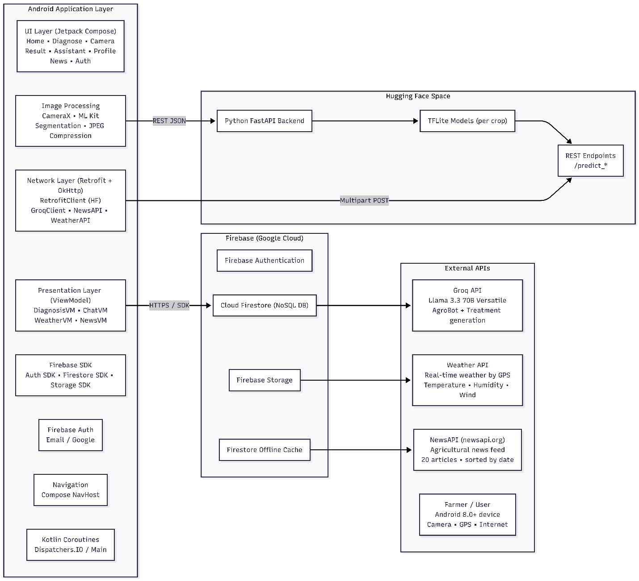
Figure 3.1 – System Level Architecture Diagram

3.2 Sub-System / Component / Module Level Architecture
This section breaks down the major components of the Agro Guard system and their interactions using modern Android standards.

Mobile Application Components
The Android application follows Google's Guide to App Architecture:
- UI Layer (Jetpack Compose):
  - LoginScreen, SignUpScreen: Authentication screens with email/password and Google Sign-In
  - HomeScreen: Weather display, quick actions (AgroBot, News, Camera launch)
  - DiagnoseScreen: Crop selection (Corn, Tomato, Potato, Apple, Orange) and image capture/upload
  - CameraScreen: CameraX-based photo capture
  - ResultScreen: Displays disease name, confidence score, and Groq-generated treatment advice
  - AssistantScreen: AgroBot AI chatbot UI
  - NewsScreen: Agricultural news feed
  - ProfileScreen: EditProfileScreen, FAQScreen — User profile management

- Presentation Layer (ViewModel):
  - DiagnosisViewModel: Handles image processing (ML Kit leaf segmentation), multipart upload to Hugging Face API, and Groq API call for treatment text.
  - ChatViewModel: Manages AgroBot conversation state and Groq API calls.
  - WeatherViewModel: Fetches and exposes weather data based on device location.
  - NewsViewModel: Fetches and exposes agricultural news from NewsAPI.

- Data Layer (Network Clients):
  - RetrofitClient: Singleton Retrofit instance targeting the Hugging Face inference server with 60-second timeouts.
  - GroqClient: Singleton Retrofit instance targeting api.groq.com for AI chatbot and treatment generation.
  - GroqApiService: Defines POST call to /openai/v1/chat/completions with the Llama 3.3 70B model.

Component Interaction Diagram (MVVM)

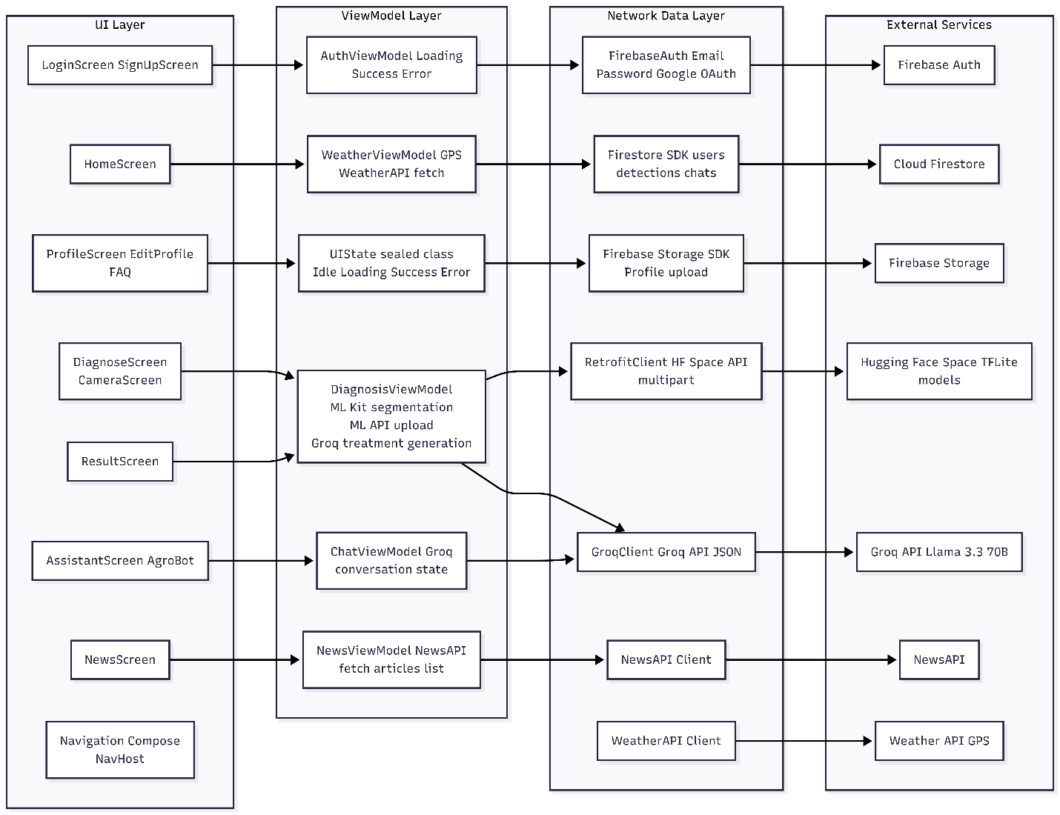
Figure 3.2 – MVVM Component Interaction Diagram

3.3 Sub-Component / Sub-Module Level Architecture (1…n)

3.3.1 Authentication System (Firebase)
The system uses Firebase Authentication for secure identity management.
- Registration: Full name, email, and password fields. Email/password validation handled in SignUpScreen. Upon successful registration, a corresponding user document is created in the users collection in Firestore.
- Google Sign-In: Integrated via GoogleSignIn SDK and FirebaseAuth.GoogleAuthProvider. Launched from both LoginScreen and SignUpScreen.
- Session: Managed automatically by the Firebase SDK. FirebaseAuth.getInstance().currentUser persists across app restarts.
- Token Management: Firebase handles token refresh automatically.

3.3.2 ML Inference Engine (Remote – Hugging Face)
- Primary Inference: The Android app processes the image locally using ML Kit Subject Segmentation to isolate the leaf, compresses it to JPEG, then sends it as a multipart HTTP POST to the Hugging Face-hosted server. The server runs the appropriate TFLite model (selected based on crop type) and returns a JSON response containing the disease name and confidence score.
- Crop Endpoints: The ApiService uses a dynamic @Path parameter to route requests to the correct endpoint.
- On-Device Inference: Not implemented. All model inference is performed server-side. The org.tensorflow:tensorflow-lite library is NOT a dependency of this application.
- Treatment Generation: After receiving the diagnosis from the Hugging Face server, the DiagnosisViewModel calls the Groq API to generate tailored treatment advice, which is displayed on the ResultScreen.

3.3.3 API Integration Manager (Retrofit)
All non-Firebase network calls are handled by Retrofit with OkHttp.
- RetrofitClient: Targets the Hugging Face inference server. Handles multipart image uploads for disease detection.
- GroqClient: Targets api.groq.com. Handles JSON chat completion requests for both AgroBot conversations and treatment text generation.
- Timeouts: Both clients are configured with 60-second connect, read, and write timeouts to accommodate server processing time.
- Error Handling: try-catch blocks within Coroutines handle IOExceptions and HttpExceptions, surfacing errors to the UI via UiState.Error.

3.3.4 Image Processing Pipeline (Kotlin/Coroutines)
- Capture: Uses CameraX API for lifecycle-aware camera control (CameraScreen).
- Selection: Uses ActivityResultContracts.PickVisualMedia for secure gallery access.
- Leaf Isolation: ML Kit Subject Segmentation (FallbackGreenMask as fallback) is applied to remove the background and isolate the leaf (LeafBackgroundRemover / ImageProcessor utility classes).
- Compression: Images are compressed to JPEG before being sent as multipart body to the API.
- Asynchronous: All image operations run on Dispatchers.IO to prevent UI freezing.

3.3.5 Database Schema (Firestore)
Firestore is a NoSQL document database. The schema is optimized for reads.
Collections:
- users (Collection)
  - Document ID: uid (from Firebase Auth)
  - Fields: email, name, createdAt, profileImageUrl
- detections (Collection)
  - Document ID: Auto-generated
  - Fields: userId (index), imageUrl, diseaseName, confidence, timestamp, plantType
- chats (Collection)
  - Document ID: Auto-generated
  - Fields: userId, message, sender ("user" or "bot"), timestamp

4. Design Strategies

4.1 Strategy 1…n

4.1.1 Authentication Strategy
- Implementation: Firebase Authentication (Email/Password + Google Sign-In).
- Why: Reduces backend boilerplate, provides free tier Email auth and Google OAuth, and integrates seamlessly with Firestore security rules.

4.1.2 Remote ML Inference Strategy
- Implementation: TFLite models are hosted and served from a Hugging Face Space (Python backend). The Android app sends images via Retrofit multipart POST and receives JSON diagnosis results.
- Why: Eliminates the need to bundle large ML model files in the APK, allows server-side model updates without requiring app updates, and offloads computation from the device.

4.1.3 AI Chatbot Strategy (Groq API)
- Implementation: AgroBot is powered by the Groq API using the Llama 3.3 70B Versatile model. Requests are made via GroqClient (Retrofit) with conversation history passed in each call.
- Why: Provides fast inference for agricultural Q&A without managing an LLM server. The same API is also used to generate treatment recommendations after disease detection.

4.1.4 MVVM Architecture
- Objective: Separation of concerns and testability.
- Async: Kotlin Coroutines replace RxJava for handling asynchronous operations including API calls, image processing, and Firebase reads/writes.
- State Management: UiState sealed class (Idle, Loading, Success, Error) drives UI rendering in Compose.

4.1.5 Migration to Native Android (Kotlin)
- Performance: Native code runs faster than JS bridge solutions, especially for image processing.
- Camera: CameraX offers more stable and device-agnostic control over hardware.
- UI: Jetpack Compose offers a modern, declarative UI toolkit that is type-safe and compiled.

4.1.6 Deployment Architecture
The Android app is distributed via Google Play Console. The backend is split between Firebase (Serverless) and the Hugging Face Space (ML inference server).

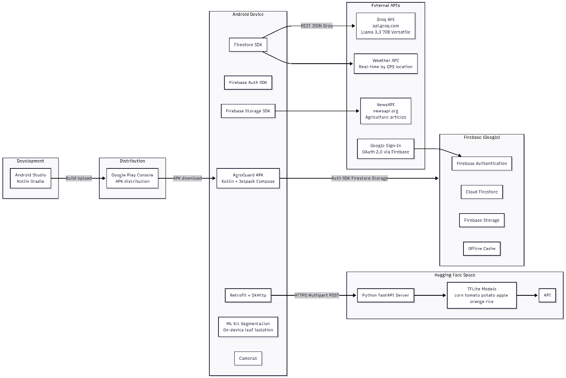

Figure 4.1.6 – Deployment Architecture Diagram

5. Detailed System Design
The detailed system design provides a comprehensive architectural blueprint of the AI Assistant for Plant Disease Diagnosis, presenting multiple design perspectives that define system structure, behavior, and data management.

- Class Diagram: The system defines classes across multiple modules including User Management, Disease Detection, ChatBot, Weather Services, News, and Location. Each class specifies relevant attributes and methods, while UML relationships illustrate interactions and dependencies between system components.
- Sequence Diagram: The sequence diagrams illustrate six core system workflows: Registration, Login, Weather Display, Disease Detection, ChatBot Interaction, and Logout. Each diagram presents step-by-step message flows between the interacting system components.
- State Transition Diagram: The state transition diagram maps the application states and user navigation flow from launch through various features, highlighting decision points, loop-back states, and error-handling transitions.
- Logical Data Model: The logical data model presents the conceptual data structure of the system, identifying key entities such as User, Disease, Treatment, and DetectionResult, along with the relationships among them.
- Physical Data Model: The physical data model defines the actual database implementation using Firestore (NoSQL), specifying collections, fields, and relationships.
- Detailed GUIs: The detailed GUI designs provide visual representations of all major application screens, ensuring a consistent, intuitive, and user-friendly experience.

5.1 Class Diagram:

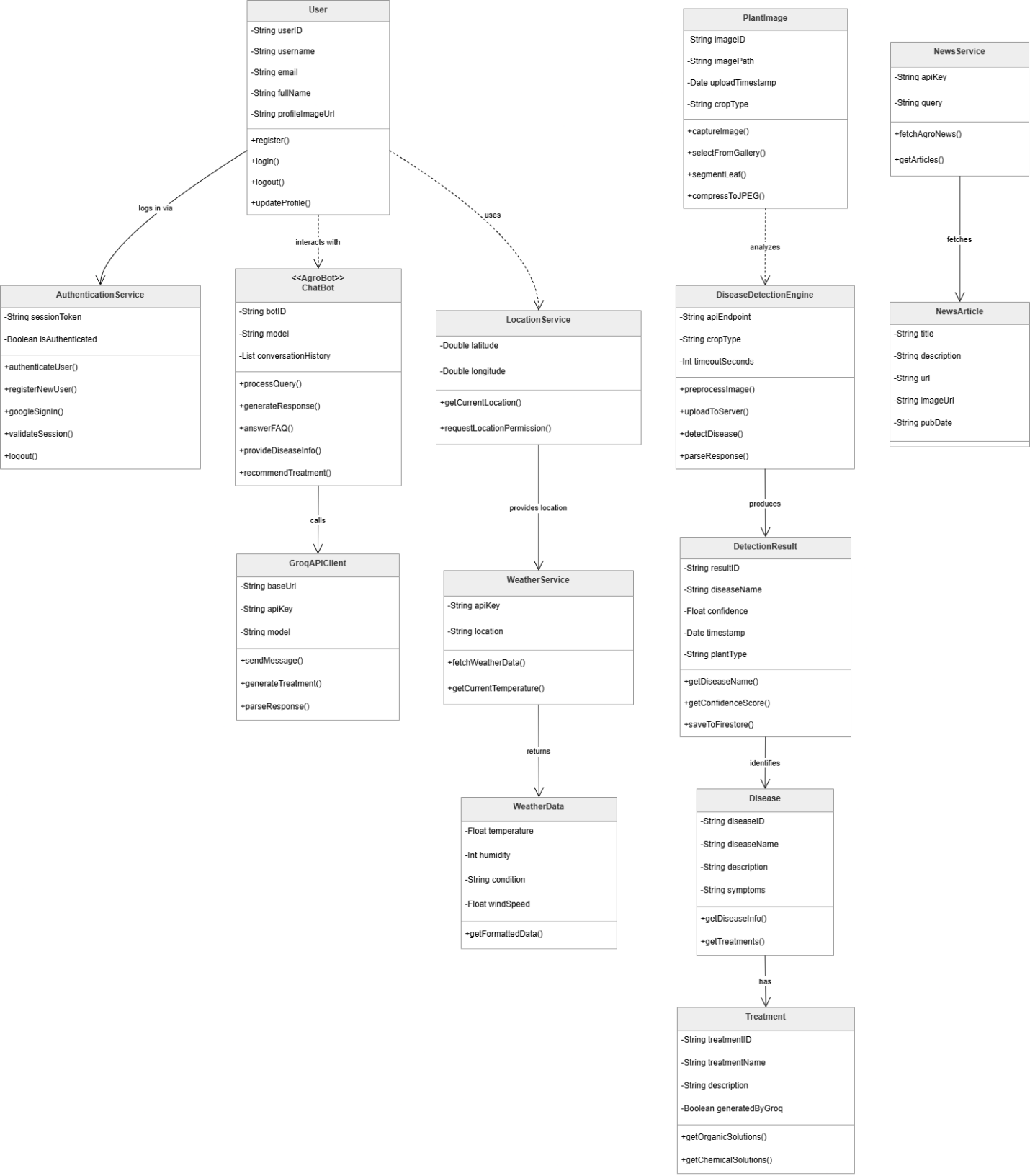
Figure 5.1 – Class Diagram

5.2 Sequence Diagram:

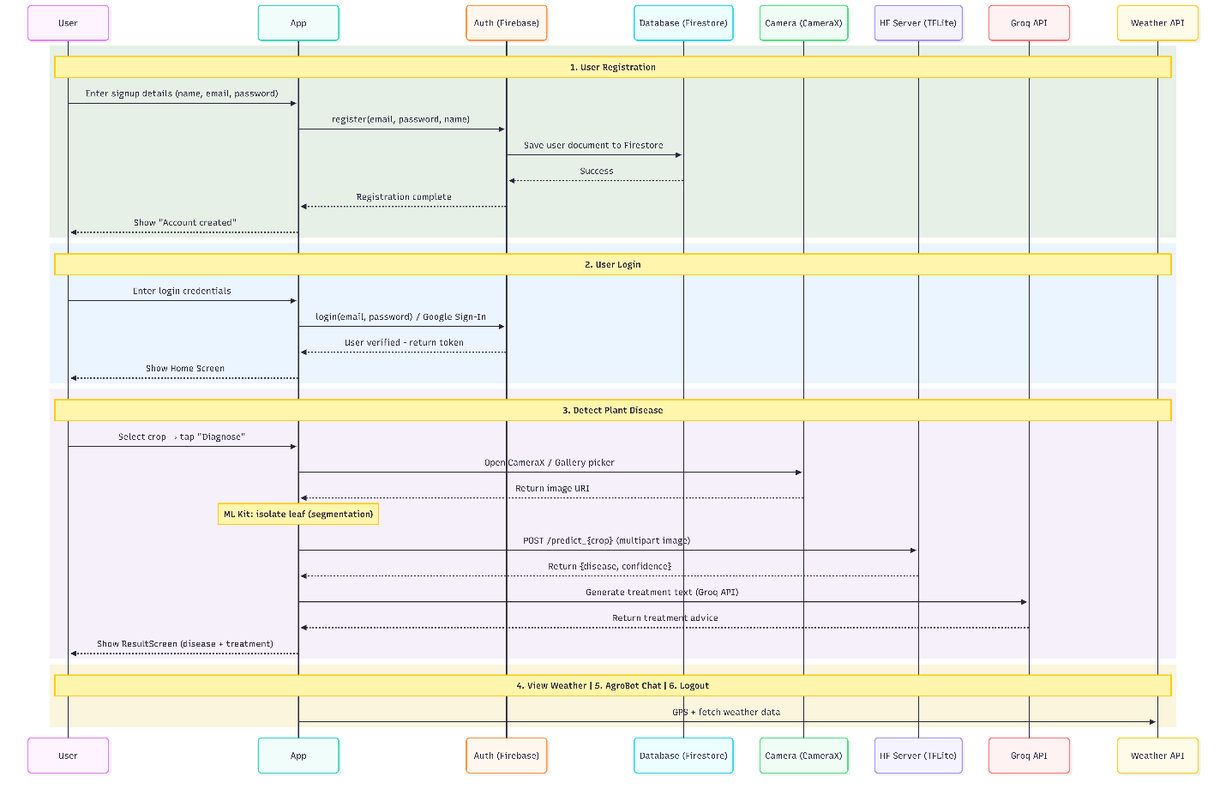

Figure 5.2 – Sequence Diagram

5.3 State Transition Diagram:

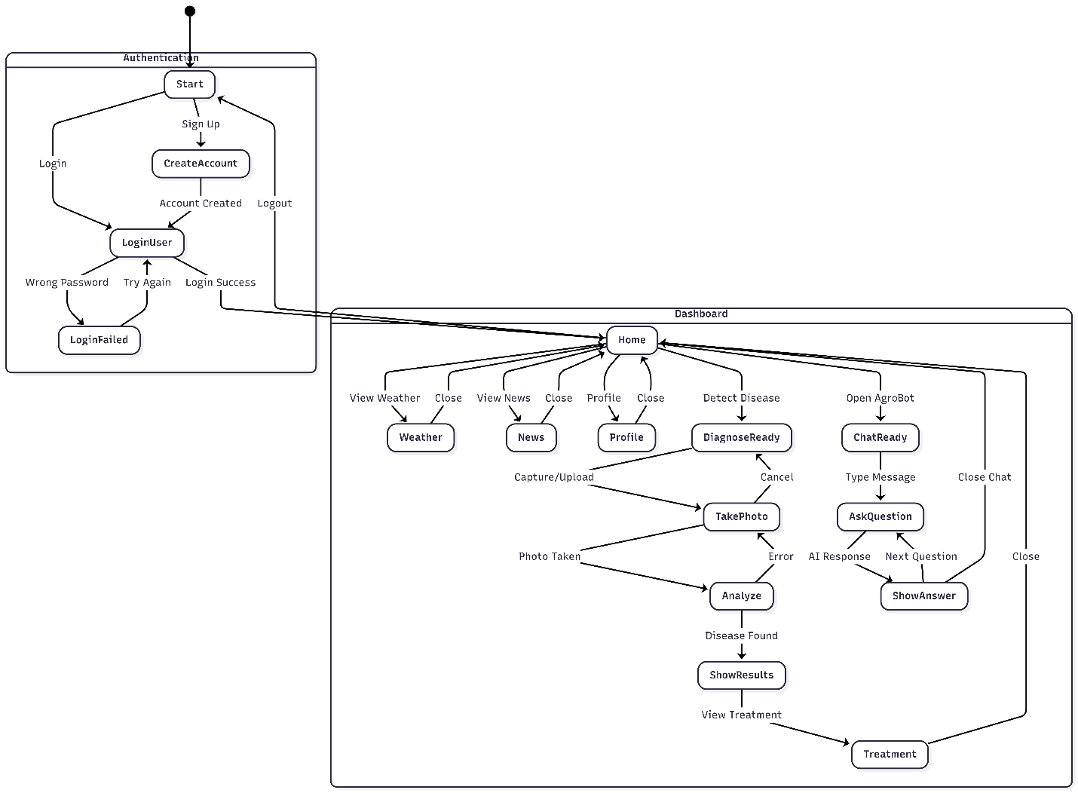

Figure 5.3 – State Transition Diagram

5.4 E/R Diagram:

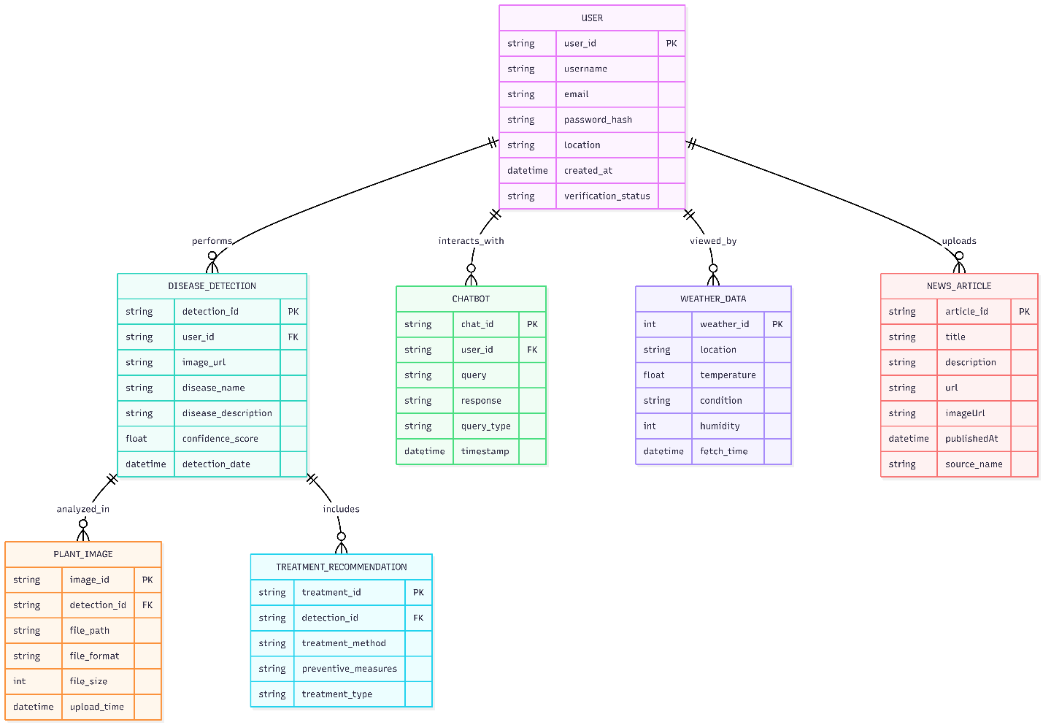

Figure 5.4 – E/R Diagram

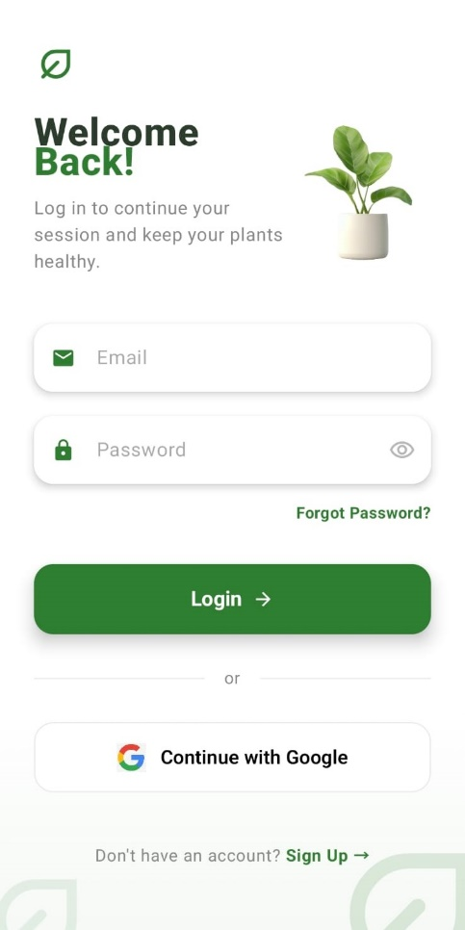
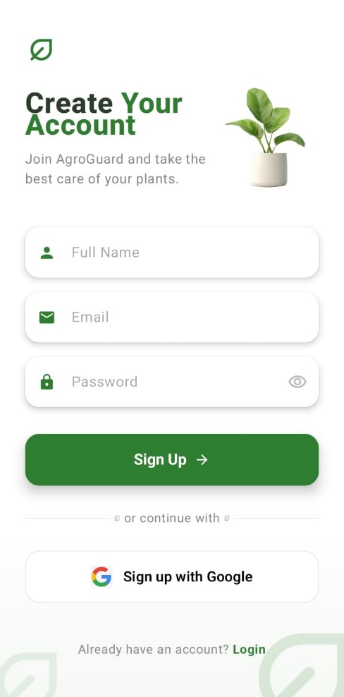
5.5 Graphical User Interface:

A. (Account Creation Screen) B. (Login Scree)

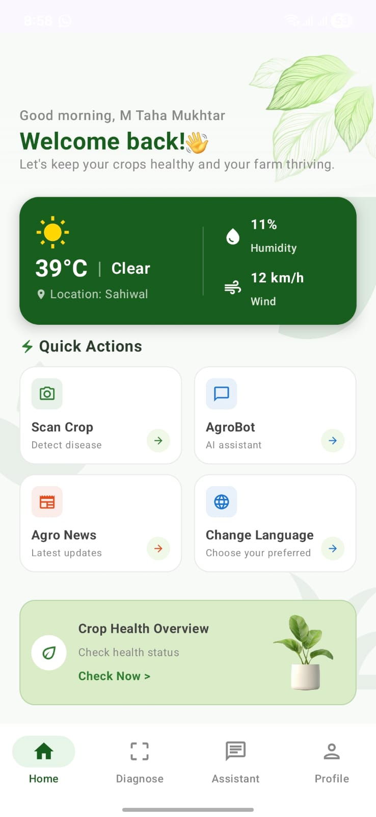
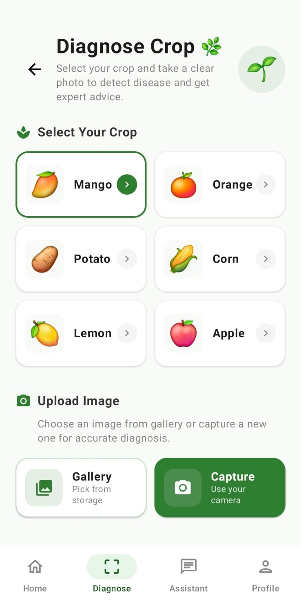

C. (Home Screen) D. (Diagnosis Screen)

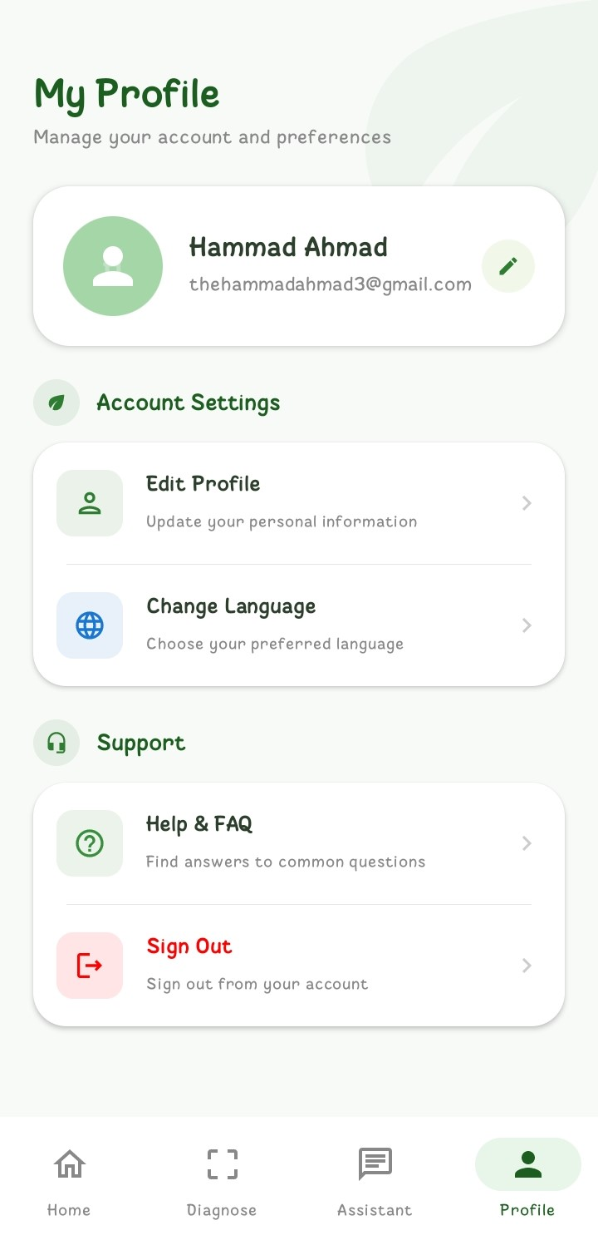
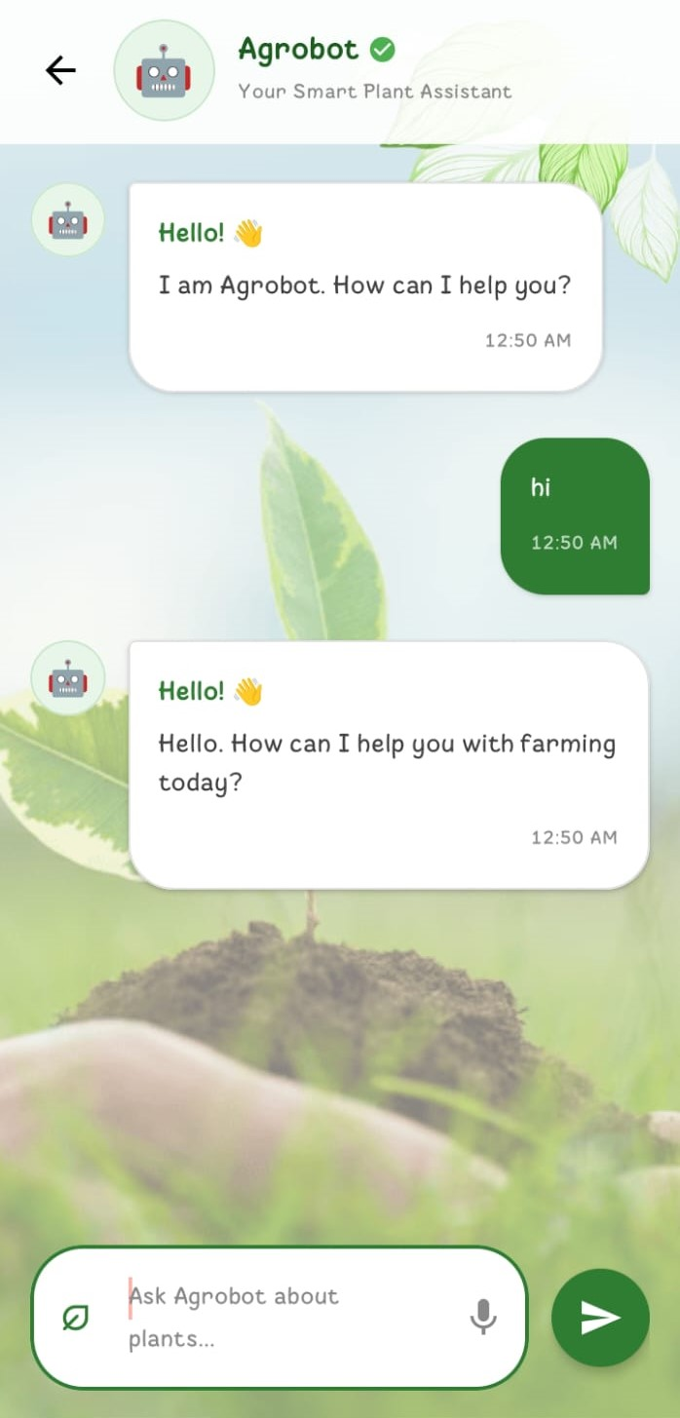

E. (Assistant Screen) F. (Profile Screen)

6. References

Ref. No. | Document Title | Date of Release/ Publication | Document Source
Group40 | Project Proposal | Oct 10, 2025 | https://github.com/mtahamukhtar2-ui/FYP/...
Group40 | SRS | Oct 20, 2025 | https://github.com/mtahamukhtar2-ui/FYP/...
Group40 | Diagrams | Dec 15, 2025 | https://github.com/mtahamukhtar3-star/FInal-Diagrams.git

